|  |  |  |  |  |  |
| --- | --- | --- | --- | --- | --- |
| Identify strong TR &  EM | 3. TRIGGERS  What triggers customers to act? i.e. seeing their neighbour installing solar panels, reading about a more efficient solution in the news.    User can predict the correct valuation of the car by their own like olx,car24 and other car resale value prediction websites by using model, year, owner, etc. | TR | 10. YOUR SOLUTION SL  If you are working on an existing business, write down your current solution first, fill in the canvas, and check how much it fits reality.  If you are working on a new business proposition, then keep it blank until you fill in the canvas and come up with a solution that fits within customer limitations, solves a problem and matches customer behaviour.    ● The main aim of this project is to predict the price of used cars using the Machine Learning  (ML) algorithms and collection data’s about different cars. The project should take parameters related to used car an inputs and enable the customers to make decisions by their own.  8.CHANNELS OF BEHAVIOUR  CH | 1. 1-ONLINE   What kind of actions do customers take online? Extract online channels from #7  8.2 -OFFLINE  What kind of actions do customers take offline? Extract offline channels from #7 and use them for customer development.   * + Customer should predict the worth of the car by using different parameters given by the owner.   + User should confirm the details provided about the vehicle in RTO online.   + User can decide by seeing the exterior and interior condition of the car.User can test the performance of the car and to buy it up in a affordable price based on its condition. |  |

Project Title: Car Resale Value Prediction Project Design Phase-I - Solution Fit Template Team ID: PNT2022TMID36315

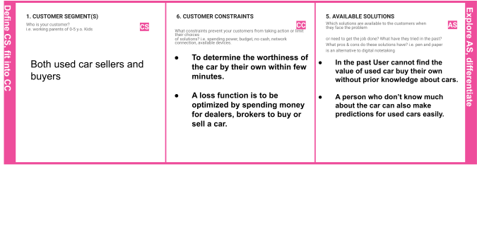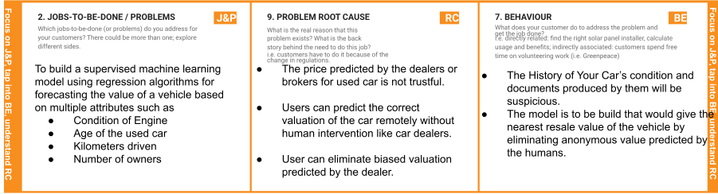

|  |  |  |  |  |
| --- | --- | --- | --- | --- |
|  | 4. EMOTIONS: BEFORE / AFTEREM  How do customers feel when they face a problem or a job and afterwards?  i.e. lost, insecure > confident, in control - use it in your communication strategy & design.    Before:  User will be in fear about the biased values predicted by the humans based on the condition of the car. After:  User can determine the worthiness of the car by their own without human intervention. |  |  |  |